OSI Reference model

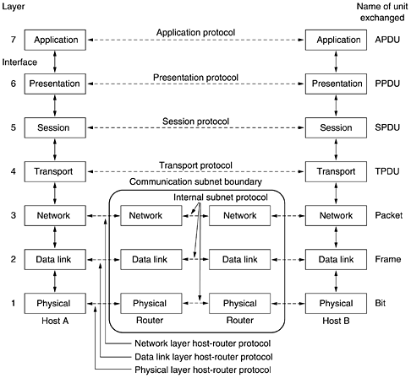

Presentation layer
Concerned with syntax and semantics of the information transmitted.

Session layer
Allows user on different machines to establish session between them.

